- Write a SQL query to find customers who are either from the city 'NewYork' or
who do not have a grade greater than 100. Return customer_id, cust_name, city, grade, and salesman_id.

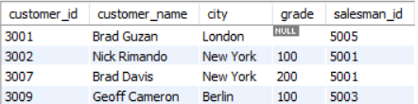

- Write a SQL query to find all the customers in ‘New York’ city who have a grade value above 100. Return customer_id, cust_name, city, grade, and salesman_id.

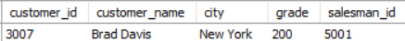

- Write a SQL query that displays order number, purchase amount, and the achieved and unachieved percentage (%) for those orders that exceed 50%of the target value of 6000.

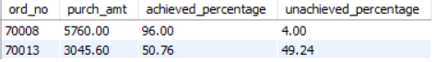

- Write a SQL query to calculate the total purchase amount of all orders. Return total purchase amount.

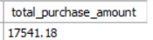

- write a SQL query to find the highest purchase amount ordered by each customer. Return customer ID, maximum purchase amount.

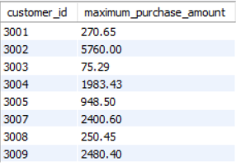

- write a SQL query to calculate the average product price. Return average product price.
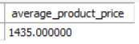

- write a SQL query to find those employees whose department is located at ‘Toronto’. Return first name, last name, employee ID, job ID.
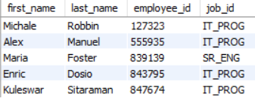

- write a SQL query to find those employees whose salary is lower than that of employees whose job title is "MK_MAN". Exclude employees of the Jobtitle ‘MK_MAN’. Return employee ID, first name, last name, job ID.
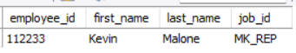

- write a SQL query to find all those employees who work in department ID27 or ID57. Return first name, last name, department number and department name.
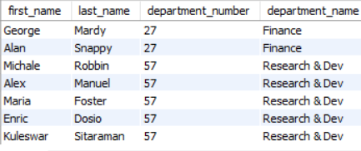

- write a SQL query to calculate the average salary, the number of employees
receiving commissions in that department. Return department name, average salary and number of employees
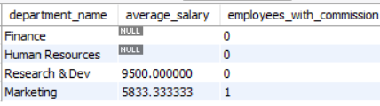

- write a SQL query to find out which employees have the same designation as the employee whose ID is 169. Return first name, last name, department ID and job ID.
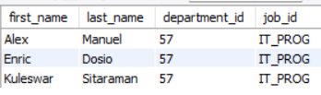

- write a SQL query to find those employees who earn more than the average salary. Return employee ID, first name, last name.
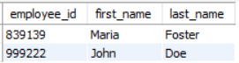

- write a SQL query to find all those employees who work in the Finance department. Return department ID, name (first), job ID and department name.
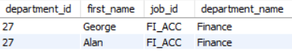

- From the following table, write a SQL query to find the employees who earn less than the employee of ID 182. Return first name, last name and salary.
SELECT
EMP_FNAME AS first_name,
EMP_LNAME AS last_name,
salary
FROM employee_details
WHERE salary < (
SELECT salary
FROM employee_details
WHERE EMP_IDNO = 182);

- Create a stored procedure CountEmployeesByDept that returns the number of employees in each department.
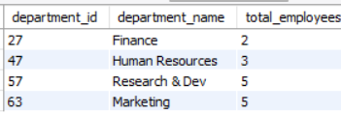

- Create a stored procedure Add New Employee that adds a new employee to the database.
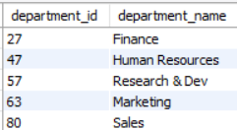

- Create a stored procedure Delete Employees By Dept that removes all employees from a specific department.
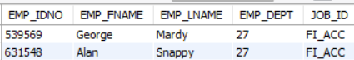

- Create a stored procedure Get Top Paid Employees that retrieves the highest-paid employee in each department.
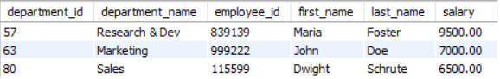

- Create a stored procedure Promote Employee that increases an employee’s salary and changes their job role.
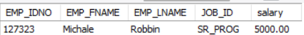

- Create a stored procedure Assign Manager to Department that assigns a new manager to all employees in a specific department.
